A Strategic Action Program (SAP) of the Sulu-Celebes (Sulawesi) Large Marine Ecosystem

Seascape Approach to Securing Coral Reef Fishery and Biodiversity Resources in the Sulu-Sulawesi Seascape

More productive fisheries, more effective local community climate adaptation, enhanced food security and greater biodiversity conservation can be achieved in a cost-neutral way simply by Coral Triangle countries coordinating where they establish MPAs to reach their Aichi target.

The Coral Triangle Initiative provides an established set of institutional arrangements for facilitating this regional collaboration that will return greater value to each country than each acting independently.

Challenge:
Many of the world’s poorest people live in close proximity to coral reefs and depend on them for food, flood defence, and livelihoods. Reef fisheries are heavily exploited yet their productivity is declining as a result of rising sea temperatures, which cause coral bleaching and habitat degradation. Indeed, degraded reefs are only capable of providing one third the level of food as healthy reefs. Failure to address the impacts of climate change on coral reefs will further undermine food security for hundreds of millions of people. Moreover, climate impacts on reefs are exacerbating losses of biodiversity, increasing levels of coastal inundation from seawater, and impacting tourism. These are global problems but particularly acute in SE Asia and the Pacific where resource dependence is exceptionally high.
Opportunity:
Coral reef management innovations developed in Australia and the Coral Triangle provide a practical means of adapting to climate change impacts. There are two elements to the approach. The first recognises that climate change impacts on reefs vary and some areas are far less impacted than others. Natural refugia from impacts can be mapped from satellite imagery. The second element considers the connectivity of marine resources among reefs. Both coral and fish larvae are transported on coastal currents. Although these transportation corridors are complex, they are now being mapped and used to identify important sources of replenishment (i.e., reefs whose offspring flow to and replenish many reefs downstream). Taken together it is possible to identify and then protect those so-called ‘keystone’ reefs of exceptional importance in driving the recovery of more vulnerable reefs.
Targeting protection to keystone coral reefs is already being used to help Australia’s Great Barrier Reef recover from recent bleaching events. Divers deployed to control crown-of-thorns starfish are prioritising reefs that help others recover. But the ideas behind this approach are also being used to revolutionise the design of Marine Protected Areas (MPAs) to identify Fishery Replenishment Zones (FRZs). In much of Asia and the Pacific, reef fishery resources are managed using MPAs but the advent of connectivity data has allowed their design to be improved so that protection can be directed to the source reefs that maintain the flow of new fish to important fishing grounds. Operational approaches to this problem are now routinely applied as part of marine spatial planning in Indonesia and have begun to be adopted in the Philippines. They are transferable to much of SE Asia and the Pacific.
Of particular relevance is every country’s requirement to protect 10% of their marine area under the Convention on Biological Diversity Aichi Target 11. Most jurisdictions are actively pursuing this goal and extending their coverage of MPAs. The most accurate fisheries models of coral reefs lend strong support to the notion that even a 10% level of protection can help rebuild heavily exploited reef fisheries. The opportunity, therefore, is to shape the design of MPAs under the Aichi framework so that keystone reefs for coral recovery are protected to maintain high habitat quality as well as creating Fisheries Replenishment Zones that reinforce food security and underpin livelihoods (Figure overleaf). Moreover, the 10% Aichi target will continue to morph into new targets under discussion for the year 2030 (e.g., 30% protection).
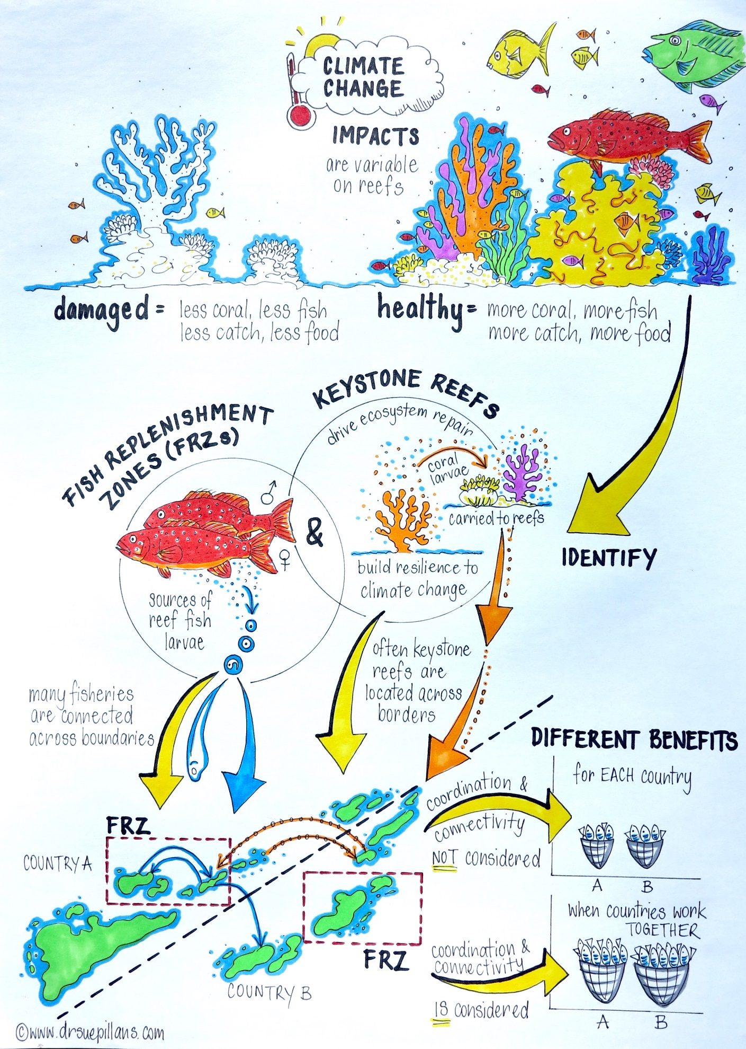
An important benefit of tackling food security challenges using MPAs is that they simplify the governance needed to achieve cooperation across the seascape. Virtually all fishery resources straddle international boundaries. The management of migratory pelagic stocks is usually coordinated by regional fisheries management organisations (RFMOs) that can be difficult to establish and expensive to maintain. Yet, coordination of each country’s MPA design can, in principle, deliver Fisheries Replenishment Zones that have mutual benefits without requiring an extra-governmental body. In short, each country pursues its domestic MPA agenda but coordinates their placement to maximise shared benefits with neighbours. The benefits will be realised by a diversity of reef users including fishers (more robust catch) and the tourism sector (higher biodiversity, more stable coastal infrastructure). Moreover, the approach will help galvanise local adaptation to climate change because it provides a pathway for implementation; the lack of which has constrained action in the past. Specifically, it is widely recognised that cognitive dissonance can occur when people are confronted with a problem for which they perceive no solution. In these cases, action to address the problem is limited even though the existence of the problem is accepted. By providing solutions, this project provides a practical means of garnering action to adapt coastal livelihoods for climate change.
The proposal:
Scope and goals
The Asia-Pacific region is home to several multi-jurisdictional priority seascapes including the Sulu-Sulawesi Seascape (Indonesia, Malaysia, Philippines), Lesser Sunda (Indonesia, Timor-Leste), and the Bismarck-Solomons Marine Ecoregion (Indonesia, PNG, Solomon Islands).
The project outlined here can be adapted for any of these seascapes though there has been considerable progress in the Sulu-Sulawesi Seascape (SSS) after a detailed workshop for practitioners, governments, and scientists in 2018 under the auspices of the Coral Triangle Initiative on Coral Reefs, Fisheries and Food Security (CTI-CFF). The specific objectives are:
1. Enhance food security and biodiversity by creating a climate-resilient, management plan for coral reefs and associated small-scale fisheries that spans borders.
2. Create and adopt regional guidelines of best practice for climate adaptation for coral reefs and fisheries in a seascape context. Share with other seascape projects operating at a regional scale.
3. Strengthen a regional network of practitioners and scientists to improve the provision of evidence-based policy for coastal biodiversity in connected seascapes
4. Support the fulfilment of the UN Aichi Target 11 for the multi-national network

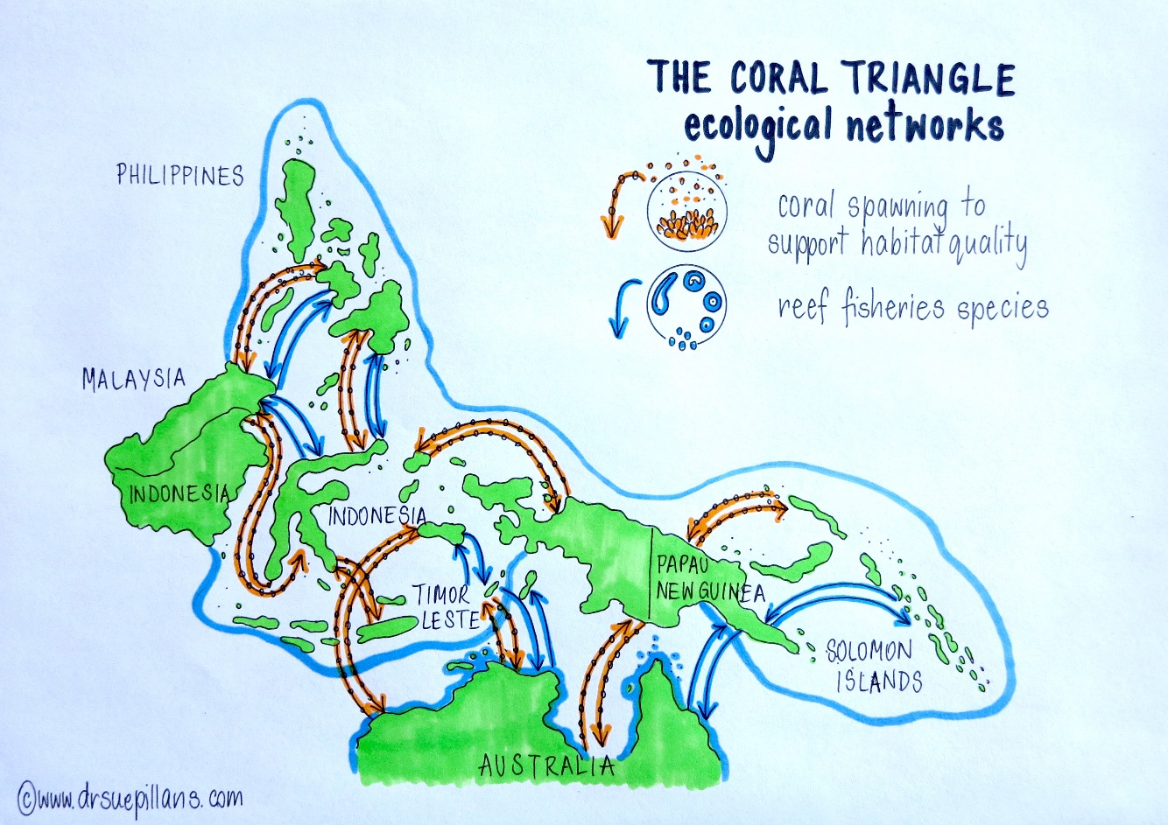

Expected impacts of the project
Nature of Impact | Within 5 Year Life of Project | Within 10 Years of Completion
Policy | - Successful implementation of UN Aichi Target 11 with demonstrable benefits to communities  - Development of new regional policy under the CTI that sets out regional cooperation for rebuilding coastal fisheries | - Seascape considerations embodied in SDGs and CBD  - Support for the next agenda (30% protection by 2030)  - Refined fisheries management policy to account for climate change in shallow coastal areas
Management | - Implementation plan for Aichi Target 11 that integrates climate adaptation and food security  - Design for MPAs at seascape scales that span borders and form climate-resilient Fisheries Replenishment Zones  - Guidelines prepared and adopted for managing reef biodiversity, fisheries, and tourism under climate change  - Greater harmony and sharing of successful management approaches in the region | - Full adoption of seascape management plan  - Adoption of the approach in other regional seascapes  - Greater capacity of reef managers to respond to coral bleaching
Ecosystem | - Enhanced protection where it can be most effective  - Minimise degradation of habitat quality  - Higher biodiversity in MPAs  - Higher reef fish abundance | - Scaled up benefits to reef ecosystems across multiple seascapes (i.e., reduced loss of habitat quality, higher biodiversity in MPAs, elevated fish populations, greater capacity of reefs to keep up with sea-level rise)
Social & economic | - Fishers embrace role of FRZs as tool to help their livelihoods  - Stable or increased value from capture fisheries  - Greater engagement of tourism sector in the planning process given greater perceived benefits | - Fisher livelihoods more robust (higher and more consistent income) than would have been the case without carefully designed FRZs  - Better investment landscape (reduced risk) for fishery development  - Greater adaptation of the tourism sector to coral bleaching such that impacts on business are lessened  - Increased security of coastal assets (including built infrastructure) because impacts of sea-level rise on beach stability are lessened

Expected outcomes and their significance
Most countries in the priority Seascapes listed above have adaptation policies that consider climate change and food security. Yet many such policies lack a granular implementation plan to achieve their objectives. For example, it is not uncommon to find ‘deploy MPAs’ as a solution to fisheries-related concerns over food security. But MPAs can only support this objective if designed specifically to support fisheries and with enabling governance. This project will unite practitioners and regional thought leaders to achieve action while also creating a broader legacy charting how to respond to food security issues associated with connected resources and under climate change. In other words, it will provide a tested roadmap and practitioner guidelines on how to implement policy effectively.
The existence of a practical implementation plan to build resilience will also help engage fishers and the tourism sector. Fisher perceptions of MPAs are often negative, in part because the historical rationale was one of biodiversity conservation rather than rebuilding fisheries and led to fishers being excluded from fishing zones upon which they relied for livelihoods. While MPA designs attempted to minimise the inconvenience to fishers, this was distinctly different from the current approach that explicitly aims to support future fisheries productivity of key fishing grounds by safeguarding brood stocks upstream. Fishers understand this and are more willing to engage when management strategies have a transparent, tangible benefit. Stakeholders buy-in like this is essential because effective/comprehensive enforcement is usually unaffordable. In other words, steps to increase food security require a strategic reduction in fishing effort or reorientation of spatial effort and this is most likely to occur when fishers perceive clear benefits to their industry and personal livelihoods/income security.
Management practitioners will be a major beneficiary of the project. During the process of scoping the project, reef managers had the opportunity to share challenges and solutions across neighbouring countries. They described this as an empowering experience and identified a number of pressing issues that the project will help resolve. These include (1) how best to respond during a bleaching event – should tourism be restricted to sacrificial sites or distributed more broadly to lessen individual impacts? (2) where most reefs are partly damaged and conventional biodiversity metrics provide little discrimination, how should decisions to prioritise actions be taken?
The primary purpose of the UN CBD Aichi Target 11 is to improve biodiversity conservation. Yet climate change is the greatest long-term threat to coral reef biodiversity. By implementing MPA strategies that explicitly support recovery from coral bleaching events, the project will increase the biodiversity benefits associated with achieving the Aichi target. Moreover, seeing as all countries of the Coral Triangle are actively extending their MPA coverage – and will continue to do so beyond 2020 under the emerging (30 × 30 initiative) – the time is ripe to guide the process.
Alignment with GEF International Waters (IW) Priorities
The project aligns well with the Global Environment Facility IW agenda of supporting the blue economy by improving sustainability of fisheries and healthy coastal and marine ecosystems. Specifically:
a) Addresses three Problems identified under the Transboundary Diagnostic Analysis (TDA) for the Sulu-Celebes (Sulawesi) Large Marine Ecosystem: Unsustainable Fisheries, Habitat Loss and Community Modification, and Climate Change.
b) Support seascape management of marine resources across borders, which builds explicitly on the ecosystem-approach to fisheries by considering the impacts of climate change and local stressors on fisheries productivity.
c) Strengthen Coastal fisheries Policy by providing regulatory framework for sustainable fisheries under climate change and developing frameworks for how to manage and restore the effects of coral bleaching.
d) Strengthen Coastal fisheries Capacity by empowering regional and local governments to plan in a multi-jurisdictional context as well as improving their ability to adapt to climate change impacts.
e) Complement the Large Marine Ecosystems (LME) approach by developing seascape management approaches to small-scale coastal fisheries within existing LMEs.
Coastal Management: Adapts marine spatial planning to consider how it best accommodates threats to biodiversity and fisheries resources. Specifically integrates the connectivity of marine resources into planning.

Bodies of work to support the outcomes
Implementation of the project requires four principal activities, which are divided into three technical working groups and project coordination. This project structure is modelled, in part, on the current CTI-CFF organisation and will link with technical working groups. A project plan provides the logical flow from objectives to activities to outputs and outcomes (Fig. 2).
Multi-jurisdictional Working Group (MJWG)
The fundamental rationale for a seascape approach to resource management is the existence of coral and fisheries connectivity across national jurisdictions (Treml and Halpin 2012). Connections are complicated because of the region’s monsoonal weather, which periodically reverses the flow of surface currents. Therefore, connections can exist in a variety of directions depending on the time of year that an animal spawns.
The Multi-jurisdictional Planning Working Group (MJWG) will have two principal activities. The first is to quantify the levels of connectivity using models of oceanography and particle tracking to map connections of key coral and fisheries species throughout the seascape. This will result in datasets that support the identification of keystone reefs and planning for seascape benefits of MPAs.
The second activity of the MJWG is to integrate inputs from other technical WGs (Fig. 2) and provide a multi-national – yet informal – environment to coordinate national action plans so that they maximise national benefits through a ‘whole of seascape’ approach. Outputs from the Fisheries Replenishment Working Group (FWG) will quantify the benefits to be expected to each party by taking a coordinated approach to siting Fisheries Replenishment Zones as well as keystone reef protection to promote habitat quality. With participation of multiple levels of government and stakeholder involvement – local, regional and national – the MJWG will facilitate the communication and planning processes to seek approval of plans that maximise net domestic benefits. Progress will be monitored at the regional ministerial level through the annual CTI Senior Official’s Meetings.
Climate Adaptation Working Group (CAWG)
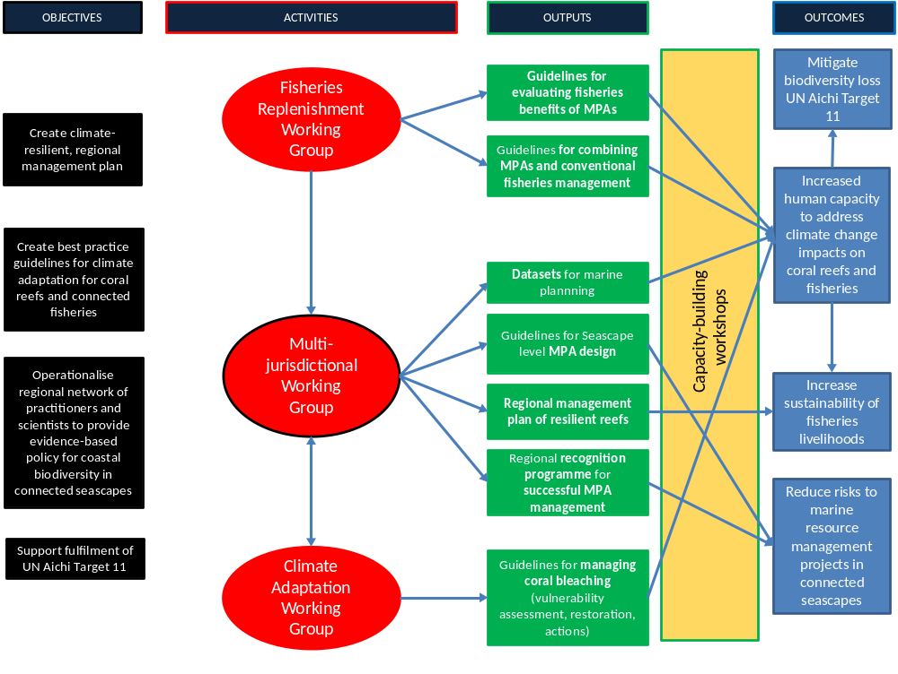Fig. 2. Project overview showing logical work flow from objectives to outcomes
The Climate Adaptation Working Group will develop MPA and restoration strategies that help reefs recover from coral bleaching. They will do this by combining connectivity data from the MJWG, analysing historical records of thermal stress, and evaluating the range of ancillary stressors across the seascape. The CAWG will also conduct exchange programmes and engage heavily with the tourism industry to identify appropriate action plans for managing bleaching events.
Fisheries Replenishment Working Group (FWG)
The FWG will contain a mix of practitioners and scientists and its mandate is to develop guidelines on how to maximise and evaluate the fisheries benefits of MPAs designated as Fisheries Replenishment Zones. This is strategically important in identifying MPA locations that offer the greatest national and benefits to fishers by considering the whole of seascape. Moreover, a sound means of evaluation the fisheries benefits of MPAs will strengthen their legitimacy and help governments monitor MPA function and take corrective action where functions are lacking. Working with the MJWG, the FWG will identify reefs with the greatest ability to support the replenishment of critical fishing grounds.
Project Management
A project management unit (PMU) will be established at the Executing Agency (EA) headquarters. The PMU’s responsibilities include coordination among technical WGs, budgetary oversight, reporting to the Implementing Agency (IA), monitoring and evaluation, sub-contracting and procurement, and communications.
The PMU will also sub-contract a national coordinating body to support on-the-ground activities in each jurisdiction.
Oversight of the project’s progress and direction will be carried out by a Board with an independent chair and high-level representation of CTI-CFF Regional Secretariat, National Country Coordinators of the CTI-CFF, IA and EAs, the Chief Scientist, and each country’s national government body with responsibility for implementing the UN Aichi Target 11.
Based on the successful experience of the World Bank / GEF Capturing Coral Reef Ecosystem Services Project, executed by the University of Queensland, communications will be sub-contracted to a partnering organisation with extensive experience in this discipline and geography.

Stakeholder breakdown
The following stakeholders will be represented per country. The precise invitees depend on the seascape.
Stakeholder | Role in Project | Stakeholder Benefit
EO, CTI Regional Secretariat | Board member | Ensure CTI alignment between CTI activities and project
CTI Technical Working Group Leads for Seascapes, Climate Adaptation, MPAs, Ecosystem-based Fisheries | MJWGs | Share the development of techniques that can be employed elsewhere in CT
National government planners (Dept. of Environment, Fisheries) | MJWGs and planning for Aichi targets | Develop a more impactful implementation strategy for Aichi targets. Coordinate with planners in other countries. Build capacity in reporting on MPA benefits
Regional government planners for marine resources and MPAs | MJWGs | Coordinate regional MPA design with local governments and communicate fishery and biodiversity benefits of alternative plans. Increase capacity in evaluating network benefits of MPAs
Local government planners for marine protection | MJWGs | Communicate values of different planning options with stakeholders including minority groups and those with limited access to decision making opportunities. Improved readiness to manage coral bleaching events and advise on restoration efforts
NGO practitioners WCS, TNC, WWF, CI, local | MJWGs | Co-implementation of MPA design where appropriate, engaging communities, and co-development of bleaching management plans, restoration strategies. Acquire new methodologies that can be applied elsewhere and increase impact
Local industry representatives from the tourism and fisheries sectors | CAWG | Participate in dialogue regarding response planning for bleaching impacts and needs for MPA design
Regional university lecturers and students under CTI University Partnership | MJWGs | Engage in technical solutions and provide advice to government. Build student capacity to deal with issues of climate adaptation and fisheries
Coastal communities associated with MPAs | Indirect beneficiary | Improved or stabilised fishery access
International planning experts for connectivity and MPA design | MJWGs | Collaboration towards providing essential data sets for marine planning with a seascape focus
University of Queensland Project Execution Office | Project management | Project management
Delegated national coordinating nodes | Project management | National activity and communication implementation and coordination

Scalability of the work
The CTI provides an unusual opportunity to achieve a broader impact, beyond the specific project seascape and duration of the work. With ministerial-level representation, the CTI facilitates regional cooperation and capacity building across at least three important Asian-Pacific seascapes. Our approach is to embed representatives from these additional seascapes within the project to facilitate the scaling up of activities. This strategy provides a low cost means of creating ownership and capacity in planners and scientists from the other key Asian-Pacific seascapes. That way, scaling up project strategies in other seascapes will become substantially easier.
In order for the work to be sustained after the project, it is imperative that training materials and training capacity are maintained in the region. That is why a key element of the project is to activate the CTI University Partnerships and strengthen their links with management planners in government and NGOs where necessary. Moreover, the CTI will outlast this project and provides the institutional framework to facilitate continued multi-jurisdictional planning. Although the second phase of the CTI Regional Plan of Action is still being finalised, elements of climate change adaptation, MPAs, ecosystem-based fisheries, and seascape planning are centrally placed throughout the draft. While future funding of the CTI is unpredictable, history implies that various national and donor support will allow this work to be continued and built on.
Gender Equity and Social Inclusion
The project will actively pursue a Gender Equity and Social Inclusion policy to ensure that project participation and benefits are as equitably distributed as possible. Specific activities will include.
- Conducting a gender analysis in target areas to understand whether there may be differential impacts on different genders of the MPAs/management plans
- Considering how we are incorporating inputs from both men and women into the MPA design, including by consulting in ways that do not create obstacles to participation based on gender
- Exploring options to ensure that benefits that result (e.g. increased fisheries resources, training/capacity building etc) are distributed equitably between women and men
- Deliberate efforts to profile women and men equitably in project communications
- Selection of NGO partners based on their credentials/training in gender
A further key aspect of social inclusion is the engagement of minority peoples within any given seascape. This will likely be undertaken by on-the-ground partners such as NGOs and local / regional government but it is an issue that needs explicit consideration and reporting on.
Implementation arrangements
Specific implementation arrangements depend on the seascape chosen and financing mechanism. Conversations to date have focused on the Sulu-Sulawesi Seascape (SSS) with a plan to seek funding from the GEF-7 International Waters. In this case, Conservation International (US) have offered to be the Implementation Agency and the University of Queensland (UQ) the Executing Agency. The UQ has executed two GEF projects for the World Bank, including the recent Capturing Coral Reef Ecosystem Services (CCRES). Indeed it is the only university certified/accredited to implement GEF projects for the World Bank.
While UQ would execute and manage the project, a project management office would be established in each country with responsibility for coordinating field activities, meetings, and regular contact with national government. This model was used successfully in the CCRES project in Indonesia and the Philippines. The majority of the practical implementation would occur through partner organisations sub-contracted to undertake various activities. Partner organisations will include the CTI Regional Secretariat, NGOs and universities. Where government engagement requires financial support (travel, training, etc) this will be handled by the EA or delegated appropriately.
Multi-jurisdictional projects are always a challenge, particularly if action requires a new legally binding agreement among countries. Importantly, the creation of the CTI provides a legal mandate with which the six countries can partner. Indeed, when previous bilateral arrangements between Philippines and Malaysia expired, they were not replaced; rather, they were superseded by the CTI agreement. In other words, regional projects in either of the three CTI seascapes already have a legal basis for coordinated action.
The existence of a legal framework means that partner countries can declare a formal network of management zones aimed to rebuild fisheries and reef health under climate change. Having said that, the project is designed to be able to achieve success even in the absence of such a formal multi-jurisdictional statement. At a minimum, each country can implement its national MPA expansion while including whole of seascape considerations as part of the design criteria. Each country will identify protected reef areas whose function is either to bolster reef habitat health (keystone reefs) or rebuild key fishing grounds (Fisheries Replenishment Zones).

Financial considerations
It is estimated that the budget needed to accomplish this work lies between US$6m – 7m. While an optimum project would support all elements simultaneously, two elements could stand alone as separate projects. These are (3) Guidelines on dealing with coral bleaching impacts, and (4) Evaluation of MPA effectiveness. Both projects will have far reaching impacts because they solve generic problems experienced by reef managers globally. Managers throughout the region are asking for a tool to demonstrate the fisheries benefits of MPAs and Fisheries Replenishment Zones.

Maps of key seascapes
